Astonathlon 2026 - Ride Route (Sprint = 1 lap/12km), Olympic = 3 laps/36km)
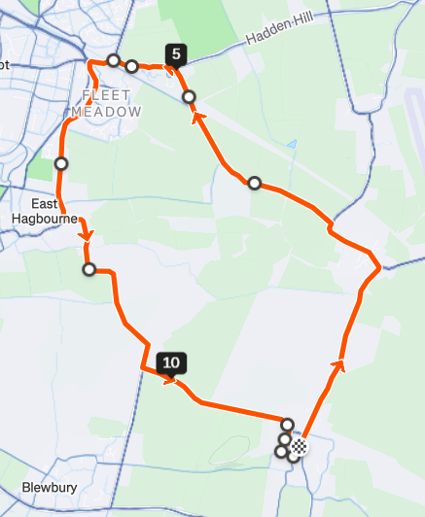
M5, 6, 7, 8
M4
M1, 2, 3

Astonathlon 2026 - Run Route (Sprint = 1 lap/5km, Olympic = 2 laps/10km)
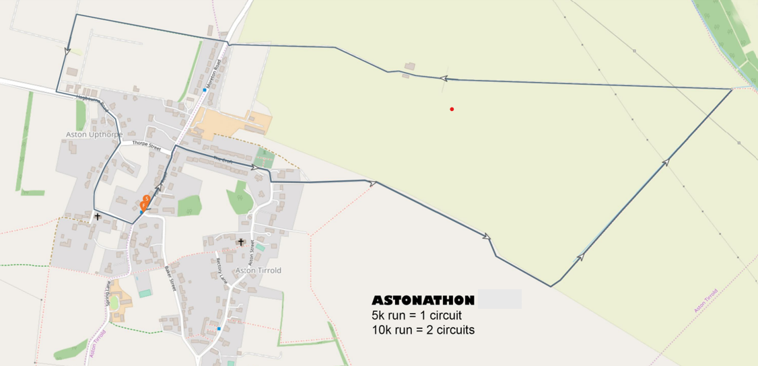
M3
M8
M7
M1,2
M6
M5

